Airlines_mini_project.R

Sai Gopi Krishna Govindarajula

Wed Jul 05 01:10:51 2017

data.df <-read.csv(paste("E:/Studies/Sai Gopi Krishna Govindarajula/Udemy/project/Airlines mini project/Gopi Airlines Project/SixAirlines.csv", sep=""))#Loading the Data set  
attach(data.df)#Attaching the Data ste  
View(data.df)#General view of the entire Data frme  
  
  
#Simple Statistical Analysis using describe funtion   
library(psych)

## Warning: package 'psych' was built under R version 3.3.3

describe(data.df)

## vars n mean sd median trimmed mad min  
## AIRLINE* 1 462 3.02 1.65 2.00 2.90 1.48 1.00  
## AIRCRAFT 2 462 0.33 0.47 0.00 0.28 0.00 0.00  
## FLIGHT_DURATION 3 462 7.55 3.54 7.75 7.54 4.82 1.25  
## MONTH 4 462 1.67 1.05 2.00 1.71 1.48 0.00  
## INTERNATIONAL 5 462 0.91 0.28 1.00 1.00 0.00 0.00  
## SEATS_ECONOMY 6 462 200.71 77.96 185.00 193.76 85.99 17.00  
## SEATS_PREMIUM 7 462 33.54 13.26 36.00 33.20 11.86 8.00  
## PITCH_ECONOMY 8 462 31.21 0.66 31.00 31.25 0.00 30.00  
## PITCH_PREMIUM 9 462 37.92 1.32 38.00 38.06 0.00 34.00  
## WIDTH_ECONOMY 10 462 17.83 0.56 18.00 17.81 0.00 17.00  
## WIDTH_PREMIUM 11 462 19.48 1.10 19.00 19.54 0.00 17.00  
## PRICE_ECONOMY 12 462 1317.06 989.81 1224.00 1231.30 1163.84 65.00  
## PRICE_PREMIUM 13 462 1832.35 1289.97 1710.00 1782.94 1852.51 86.00  
## PRICE_RELATIVE 14 462 0.49 0.45 0.38 0.43 0.42 0.02  
## N 15 462 234.25 86.88 227.00 227.69 90.44 38.00  
## LAMBDA 16 462 0.15 0.06 0.13 0.14 0.03 0.05  
## QUALITY 17 462 6.72 1.78 7.00 6.79 0.00 2.00  
## max range skew kurtosis se  
## AIRLINE* 6.00 5.00 0.59 -0.95 0.08  
## AIRCRAFT 1.00 1.00 0.74 -1.46 0.02  
## FLIGHT_DURATION 14.66 13.41 -0.05 -1.12 0.16  
## MONTH 3.00 3.00 -0.16 -1.20 0.05  
## INTERNATIONAL 1.00 1.00 -2.93 6.60 0.01  
## SEATS_ECONOMY 389.00 372.00 0.61 -0.26 3.63  
## SEATS_PREMIUM 66.00 58.00 0.25 -0.46 0.62  
## PITCH_ECONOMY 33.00 3.00 -0.03 -0.38 0.03  
## PITCH_PREMIUM 40.00 6.00 -1.48 3.43 0.06  
## WIDTH_ECONOMY 19.00 2.00 -0.03 -0.12 0.03  
## WIDTH_PREMIUM 21.00 4.00 -0.09 -0.34 0.05  
## PRICE_ECONOMY 3593.00 3528.00 0.52 -0.88 46.05  
## PRICE_PREMIUM 7414.00 7328.00 0.51 0.41 60.01  
## PRICE_RELATIVE 1.89 1.87 1.14 0.61 0.02  
## N 441.00 403.00 0.61 -0.44 4.04  
## LAMBDA 0.55 0.50 2.70 14.02 0.00  
## QUALITY 10.00 8.00 -0.51 1.67 0.08

library(ggplot2)

##   
## Attaching package: 'ggplot2'

## The following objects are masked from 'package:psych':  
##   
## %+%, alpha

## Loading required package: ggplot2  
#Seggregating different flights   
ggplot(data.df, aes(x = AIRLINE, fill = AIRLINE)) + geom_bar()

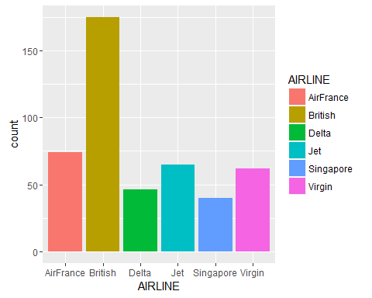

#Seggregating international and domestic flights  
ggplot(data.df, aes(x = INTERNATIONAL))+ geom_bar()

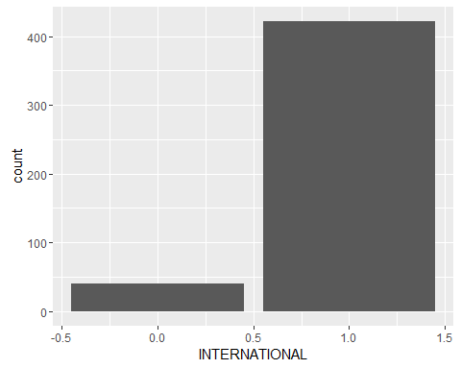

#Prices of Economy and Premium tickets  
ggplot(data.df, aes(x = PRICE_ECONOMY)) + geom_density()

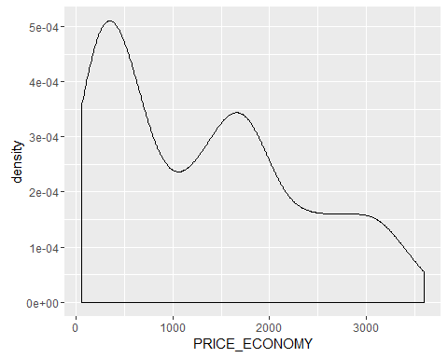

ggplot(data.df, aes(x = PRICE_PREMIUM)) + geom_density()

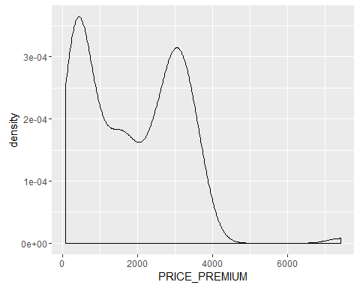

# A Scatterplot of price economy vs flight hours of travel  
# ==========  
plot(FLIGHT_DURATION,PRICE_ECONOMY,   
 col="blue",  
 main="Price economy vs flight hours",  
 xlab="Hours", ylab="Price")  
  
# Add the sample means to the Scatterplot  
# ==========  
abline(h=mean(PRICE_ECONOMY), col="dark blue", lty="dotted")  
abline(v=mean(FLIGHT_DURATION), col="dark blue", lty="dotted")  
  
# Add a regression line  
# ==========  
abline(lm(PRICE_ECONOMY ~ FLIGHT_DURATION))

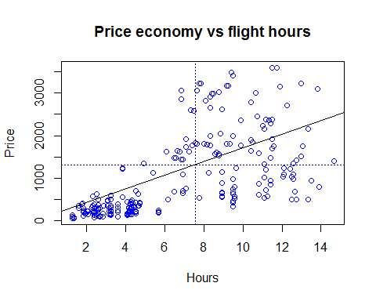

# A Scatterplot of price premium vs flight hours of travel  
# ==========  
plot(FLIGHT_DURATION,PRICE_PREMIUM,   
 col="blue",  
 main="Price economy vs flight hours",  
 xlab="Hours", ylab="Price")  
  
# Add the sample means to the Scatterplot  
# ==========  
abline(h=mean(PRICE_PREMIUM), col="dark blue", lty="dotted")  
abline(v=mean(FLIGHT_DURATION), col="dark blue", lty="dotted")  
  
# Add a regression line  
# ==========  
abline(lm(PRICE_PREMIUM ~ FLIGHT_DURATION))

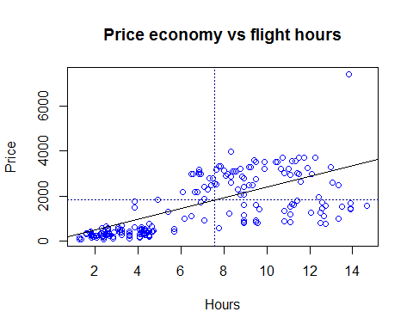

#Correlation and Correlation Matrix for Price Economy  
  
library(corrplot)

## Warning: package 'corrplot' was built under R version 3.3.3

library(gplots) # for color interpolation

## Warning: package 'gplots' was built under R version 3.3.3

##   
## Attaching package: 'gplots'

## The following object is masked from 'package:stats':  
##   
## lowess

par(mfrow=c(1, 1))  
corrplot.mixed(corr=cor(data.df[ , c(2:6, 8,10,12,15,17)], use="complete.obs"),   
 upper="ellipse", tl.pos="lt",   
 col = colorpanel(50, "red", "gray60", "blue4"))

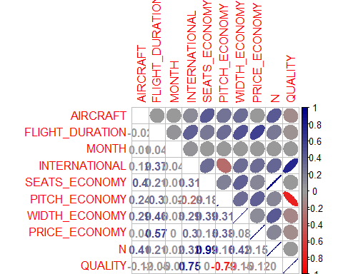

#Correlation and Correlation Matrix for Price Premium  
  
par(mfrow=c(1, 1))  
corrplot.mixed(corr=cor(data.df[ , c(2:6, 7,9,11,15,17)], use="complete.obs"),   
 upper="ellipse", tl.pos="lt",   
 col = colorpanel(50, "red", "gray60", "blue4"))

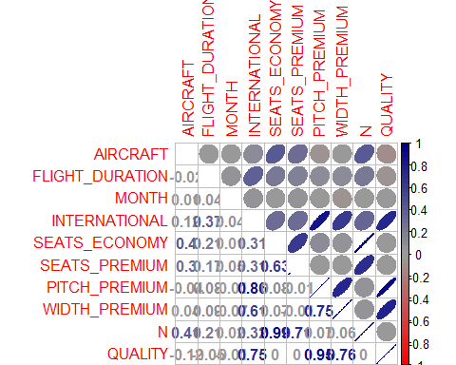

#Scatter Plot Matrix for Price Economy and Price Premium  
library(car)

## Warning: package 'car' was built under R version 3.3.3

##   
## Attaching package: 'car'

## The following object is masked from 'package:psych':  
##   
## logit

scatterplotMatrix(formula = ~ SEATS_ECONOMY + PITCH_ECONOMY + WIDTH_ECONOMY + PRICE_ECONOMY, cex=0.6,  
 data=data.df, diagonal="histogram")

## Warning in smoother(x, y, col = col[2], log.x = FALSE, log.y = FALSE,  
## spread = spread, : could not fit smooth

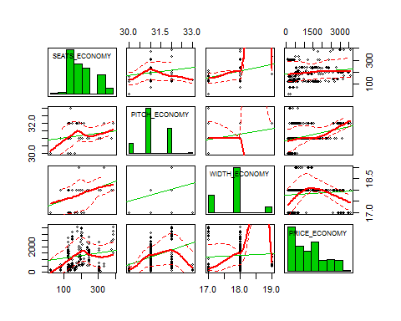

scatterplotMatrix(formula = ~ SEATS_PREMIUM + PITCH_PREMIUM + WIDTH_PREMIUM + PRICE_PREMIUM, cex=0.6,  
 data=data.df, diagonal="histogram")

## Warning in smoother(x, y, col = col[2], log.x = FALSE, log.y = FALSE,  
## spread = spread, : could not fit smooth

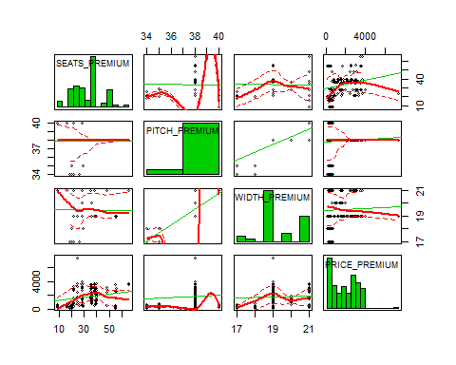

#Calculating correlations between Prices of Economy and Premium in correlation to other factors  
cor.test(PRICE_ECONOMY, PITCH_ECONOMY)

##   
## Pearson's product-moment correlation  
##   
## data: PRICE_ECONOMY and PITCH_ECONOMY  
## t = 8.8003, df = 460, p-value < 2.2e-16  
## alternative hypothesis: true correlation is not equal to 0  
## 95 percent confidence interval:  
## 0.2987210 0.4550742  
## sample estimates:  
## cor   
## 0.379605

cor.test(PRICE_ECONOMY, WIDTH_ECONOMY)

##   
## Pearson's product-moment correlation  
##   
## data: PRICE_ECONOMY and WIDTH_ECONOMY  
## t = 1.764, df = 460, p-value = 0.0784  
## alternative hypothesis: true correlation is not equal to 0  
## 95 percent confidence interval:  
## -0.009330795 0.171911298  
## sample estimates:  
## cor   
## 0.0819679

cor.test(PRICE_PREMIUM, PITCH_PREMIUM)

##   
## Pearson's product-moment correlation  
##   
## data: PRICE_PREMIUM and PITCH_PREMIUM  
## t = 1.5338, df = 460, p-value = 0.1258  
## alternative hypothesis: true correlation is not equal to 0  
## 95 percent confidence interval:  
## -0.02002801 0.16150915  
## sample estimates:  
## cor   
## 0.07133125

cor.test(PRICE_PREMIUM, WIDTH_PREMIUM)

##   
## Pearson's product-moment correlation  
##   
## data: PRICE_PREMIUM and WIDTH_PREMIUM  
## t = 1.0592, df = 460, p-value = 0.2901  
## alternative hypothesis: true correlation is not equal to 0  
## 95 percent confidence interval:  
## -0.04209336 0.13992426  
## sample estimates:  
## cor   
## 0.04932498

#Using the Boruta package to calcuate the effectiveness of different variables in Calculating the price of Economy class tickets  
eco.df <-read.csv(paste("E:/Studies/Sai Gopi Krishna Govindarajula/Udemy/project/Airlines mini project/Gopi Airlines Project/Economy_data.csv", sep=""))  
library(Boruta)

## Warning: package 'Boruta' was built under R version 3.3.3

## Loading required package: ranger

## Warning: package 'ranger' was built under R version 3.3.3

set.seed(1234) # for code reproducibility  
response <- data.df$PRICE_ECONOMY  
bor.results <- Boruta(eco.df,response,maxRuns=101,doTrace=0)  
plot(bor.results)

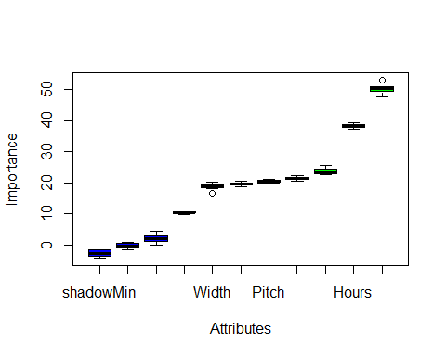

#Using the Boruta package to calcuate the effectiveness of different variables in Calculating the price of Premium class tickets  
pre.df <-read.csv(paste("E:/Studies/Sai Gopi Krishna Govindarajula/Udemy/project/Airlines mini project/Gopi Airlines Project/Premium_data.csv", sep=""))  
library(Boruta)  
set.seed(1234) # for code reproducibility  
response <- data.df$PRICE_PREMIUM  
bor.results <- Boruta(pre.df,response,maxRuns=101,doTrace=0)  
plot(bor.results)

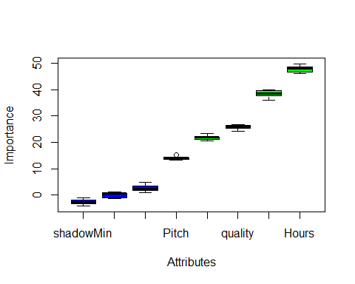

#Dividing the Data set into Test and Training Data ste  
ratio = sample(1:nrow(data.df), size = 0.25*nrow(data.df))  
Test = data.df[ratio,] #Test dataset 25% of total  
Training = data.df[-ratio,] #Train dataset 75% of total  
dim(Training)

## [1] 347 17

dim(Test)

## [1] 115 17

#Generating A Multi Variable Linear Regressional Model for Price of Economy Flights  
linear.mod<- lm(PRICE_ECONOMY~ PITCH_ECONOMY + WIDTH_ECONOMY + FLIGHT_DURATION + QUALITY + PRICE_RELATIVE, data = Training)  
summary(linear.mod)

##   
## Call:  
## lm(formula = PRICE_ECONOMY ~ PITCH_ECONOMY + WIDTH_ECONOMY +   
## FLIGHT_DURATION + QUALITY + PRICE_RELATIVE, data = Training)  
##   
## Residuals:  
## Min 1Q Median 3Q Max   
## -1503.78 -485.28 -16.78 587.93 1655.51   
##   
## Coefficients:  
## Estimate Std. Error t value Pr(>|t|)   
## (Intercept) -8566.89 3343.91 -2.562 0.0108 *   
## PITCH_ECONOMY 574.45 100.45 5.719 2.35e-08 ***  
## WIDTH_ECONOMY -580.68 69.37 -8.370 1.50e-15 ***  
## FLIGHT_DURATION 178.61 11.96 14.934 < 2e-16 ***  
## QUALITY 200.08 35.49 5.637 3.63e-08 ***  
## PRICE_RELATIVE -872.63 91.76 -9.510 < 2e-16 ***  
## ---  
## Signif. codes: 0 '***' 0.001 '**' 0.01 '*' 0.05 '.' 0.1 ' ' 1  
##   
## Residual standard error: 649.2 on 341 degrees of freedom  
## Multiple R-squared: 0.569, Adjusted R-squared: 0.5626   
## F-statistic: 90.02 on 5 and 341 DF, p-value: < 2.2e-16

#the t value of Pitch_economy and quality is positive indicating that these predictors are associated with   
#Price_economy. A larger t-value indicates that that it is less likely that the coefficient is not equal to zero purely by chance.  
#Again, as the p-value for Flight_Duration and Price_Relative is less than 0.05 they are both statistically significant in the multiple linear regression model for Price_Economy response variable.   
#The model's, p-value: < 2.2e-16 is also lower than the statistical significance level of 0.05, this indicates that we can safely reject the null hypothesis that the value for the coefficient is zero   
#(or in other words, the predictor variable has no explanatory relationship with the response variable).  
#The model has a F Statistic of 90, which is considerably high  
library(rpart)  
library(randomForest)

## Warning: package 'randomForest' was built under R version 3.3.3

## randomForest 4.6-12

## Type rfNews() to see new features/changes/bug fixes.

##   
## Attaching package: 'randomForest'

## The following object is masked from 'package:ranger':  
##   
## importance

## The following object is masked from 'package:ggplot2':  
##   
## margin

## The following object is masked from 'package:psych':  
##   
## outlier

model.forest <- randomForest(PRICE_ECONOMY~ PITCH_ECONOMY + WIDTH_ECONOMY + FLIGHT_DURATION + QUALITY + PRICE_RELATIVE, data = Training, method = "anova",   
 ntree = 300,  
 mtry = 2, #mtry is sqrt(6)  
 replace = F,  
 nodesize = 1,  
 importance = T)  
  
varImpPlot(model.forest)

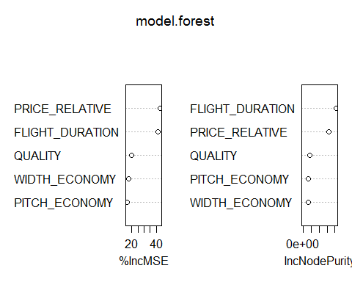

#From the VIF plot we see that Flight Duration and Price Relative are most important factors in predicitng Price Economy.  
  
#We test the model using Random Forest  
prediction <- predict(model.forest,Test)  
rmse <- sqrt(mean((log(prediction)-log(Test$PRICE_ECONOMY))^2))  
round(rmse, digits = 3)

## [1] 0.322

# Evaluation metric function  
#A custom root mean Square Function to evaluate the performance of our model  
RMSE <- function(x,y)  
{  
 a <- sqrt(sum((log(x)-log(y))^2)/length(y))  
 return(a)  
}  
  
#Implementing the Regression Tree Model   
model <- rpart(PRICE_ECONOMY~ PITCH_ECONOMY + WIDTH_ECONOMY + FLIGHT_DURATION + QUALITY + PRICE_RELATIVE, data = Training, method = "anova")  
predict <- predict(model, Test)  
RMSE1 <- RMSE(predict, Test$PRICE_ECONOMY)  
RMSE1 <- round(RMSE1, digits = 3)  
RMSE1

## [1] 0.476

#For Premium Class Tickets  
  
#Generating A Multi Variable Linear Regressional Model for Price of Premium Flights  
linear.mod<- lm(PRICE_PREMIUM~ PITCH_PREMIUM + WIDTH_PREMIUM + FLIGHT_DURATION + QUALITY + PRICE_RELATIVE, data = Training)  
summary(linear.mod)

##   
## Call:  
## lm(formula = PRICE_PREMIUM ~ PITCH_PREMIUM + WIDTH_PREMIUM +   
## FLIGHT_DURATION + QUALITY + PRICE_RELATIVE, data = Training)  
##   
## Residuals:  
## Min 1Q Median 3Q Max   
## -2073.5 -604.9 -170.4 760.1 4531.0   
##   
## Coefficients:  
## Estimate Std. Error t value Pr(>|t|)   
## (Intercept) -5499.49 4901.97 -1.122 0.263   
## PITCH_PREMIUM 155.22 148.56 1.045 0.297   
## WIDTH_PREMIUM 29.42 77.51 0.380 0.705   
## FLIGHT_DURATION 215.60 16.59 12.995 <2e-16 ***  
## QUALITY -106.15 113.77 -0.933 0.351   
## PRICE_RELATIVE -225.64 141.43 -1.595 0.112   
## ---  
## Signif. codes: 0 '***' 0.001 '**' 0.01 '*' 0.05 '.' 0.1 ' ' 1  
##   
## Residual standard error: 964.8 on 341 degrees of freedom  
## Multiple R-squared: 0.4151, Adjusted R-squared: 0.4065   
## F-statistic: 48.4 on 5 and 341 DF, p-value: < 2.2e-16

#The model has an F Statistic of 48.4 which is mediumly high  
#the t value of Pitch_premium, width_premium, Price_relative and quality is positive indicating that these predictors are associated with   
#Price_Premium. A larger t-value indicates that that it is less likely that the coefficient is not equal to zero purely by chance.  
#Again, as the p-value for Flight_Duration is less than 0.05 they are both statistically significant in the multiple linear regression model for Price_Economy response variable.   
#The model's, p-value: < 2.2e-16 is also lower than the statistical significance level of 0.05, this indicates that we can safely reject the null hypothesis that the value for the coefficient is zero   
#(or in other words, the predictor variable has no explanatory relationship with the response variable).  
  
library(rpart)  
library(randomForest)  
model.forest <- randomForest(PRICE_PREMIUM~ PITCH_PREMIUM + WIDTH_PREMIUM + FLIGHT_DURATION + QUALITY + PRICE_RELATIVE, data = Training, method = "anova",   
 ntree = 300,  
 mtry = 2, #mtry is sqrt(6)  
 replace = F,  
 nodesize = 1,  
 importance = T)  
  
varImpPlot(model.forest)

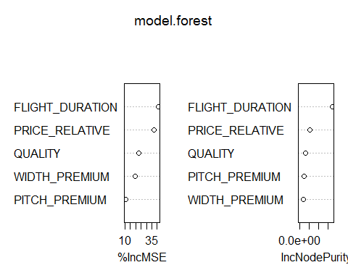

#From the VIF plot we see that Flight Duration and Price Relative are most important factors in predicitng Price Economy.  
  
# Evaluation metric function  
#A custom root mean Square Function to evaluate the performance of our model  
RMSE <- function(x,y)  
{  
 a <- sqrt(sum((log(x)-log(y))^2)/length(y))  
 return(a)  
}  
  
#Implementing the Regression Tree Model   
model <- rpart(PRICE_ECONOMY~ PITCH_ECONOMY + WIDTH_ECONOMY + FLIGHT_DURATION + QUALITY + PRICE_RELATIVE, data = Training, method = "anova")  
predict <- predict(model, Test)  
RMSE1 <- RMSE(predict, Test$PRICE_ECONOMY)  
RMSE1 <- round(RMSE1, digits = 3)  
RMSE1

## [1] 0.476